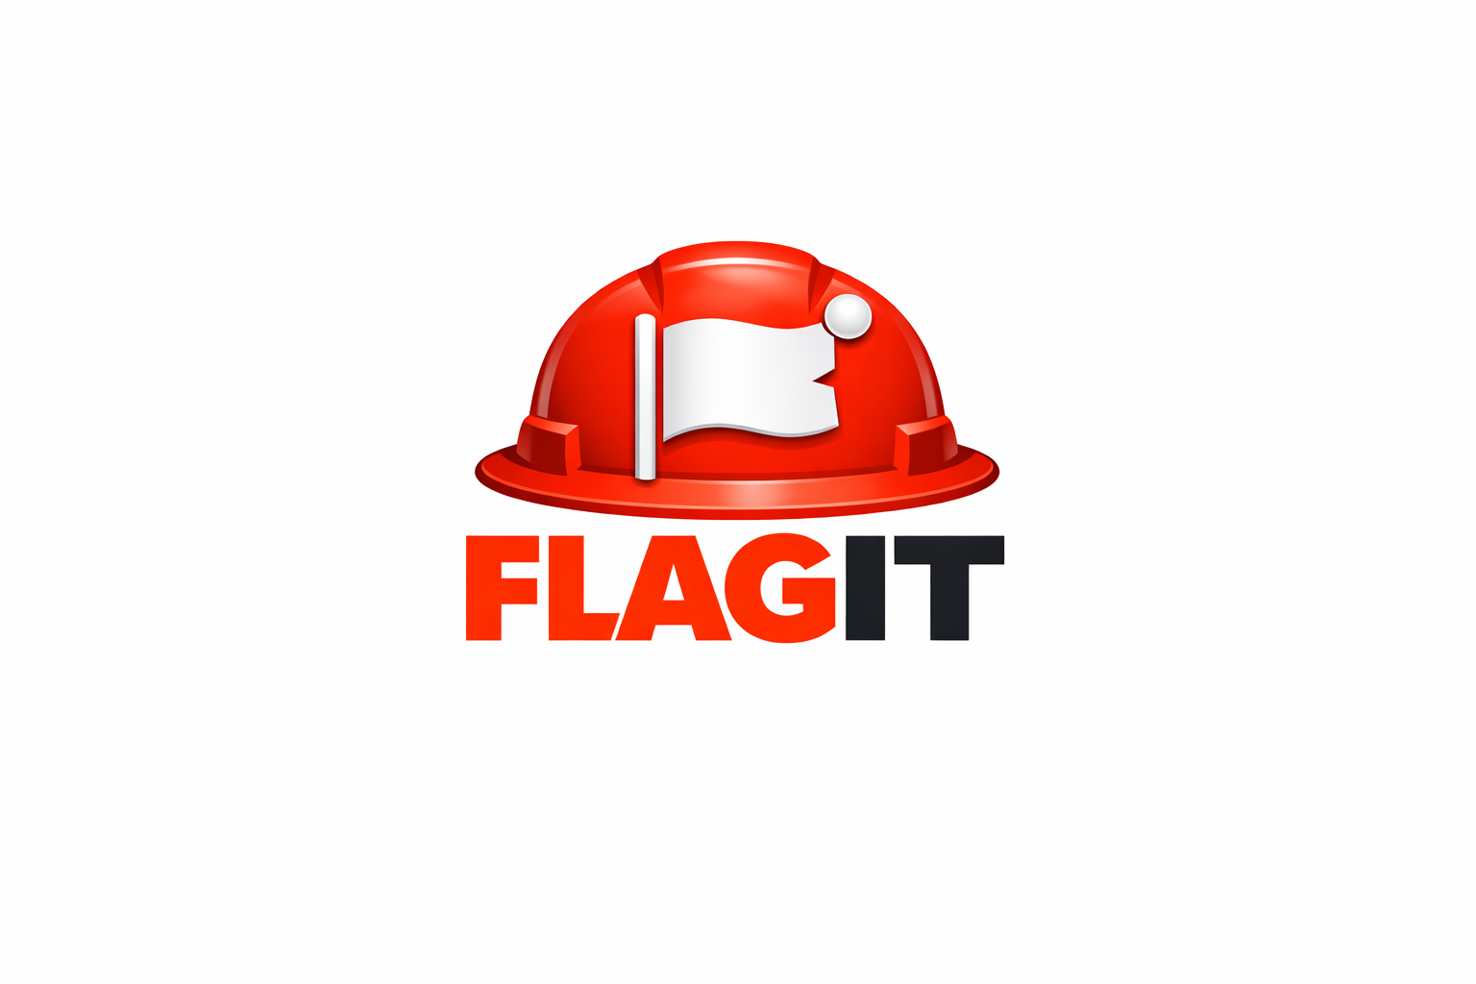
Kindness Njoku
owner & DEVELOPER
FLAAGIT Safet Management System
FLAGIT – Service Profile & Proposal
Version 1.0 | April 2026 | getflagit.com
April 1, 2026

FLAGIT – Service Profile & Proposal

1. Introduction
FLAGIT is a simple, mobile-first safety management platform designed for site teams to log, track, and report safety observations in real time.
It replaces fragmented workflows such as WhatsApp messages, Excel sheets, and manual reporting with a single, structured system.

2. What FLAGIT Solves
Most site teams currently face:
- Delayed safety reporting
- Poor visibility of open issues
- Difficulty tracking closeouts
- Time-consuming report preparation
FLAGIT addresses these by providing a centralized, real-time system.

3. Key Features
- Real-Time Safety Observation Logging
Log issues directly from mobile devices on site
- Status Tracking
Track observations as Open, In Progress, or Closed
- Dashboard Overview
View total observations, open issues, and category breakdown
- Team Management
Admin users can invite and manage team members
- Instant PDF Report Generation
Download complete safety reports instantl

4. How It Works
- A project is created and assigned an admin user
- The admin invites team members via email
- Team members log and update safety observations
- Management views progress through the dashboard
- Reports can be generated instantly at any time

5. Security & Data Handling
- Data is stored securely in a managed cloud database (Supabase)
- Application is hosted on a secure global platform (Vercel)
- Access is restricted to invited users only
- Each company’s data is isolated per project
- All communication is secured via HTTPS

6. Deployment & Onboarding
- Initial setup takes less than 10 minutes
- No installation required (web-based access)
- Admin users can onboard their teams independently

7. Proposed Pilot Engagement
We propose starting with a pilot project to demonstrate value:
- Duration: One project cycle
- Scope: Full use of FLAGIT for safety observation tracking
- Support: Setup and onboarding assistance provided

8. Commercial Proposal

Option A – Project-Based License (Short-Term Use)
Duration | Price (AED) | Ideal For
30 days | 350 | Events, inspections, short builds
3 months | 900 | Medium-term projects
6 months | 1,500 | Long-term projects without subscription

Option B – Monthly Subscription
Tier | Price (AED) | Limit | Notes
Single Project | 150/month | 1 project | Entry tier
Multi-Project (up to 3) | 420/month | Max 3 projects | AED 30 savings vs buying 3 singles
Unlimited Projects | 600–700/month (optional) | Unlimited | For large contractors

9. Benefits to Your Organization
- Faster reporting turnaround
- Improved visibility of site safety status
- Better compliance documentation
- Reduced reliance on manual tracking methods
- Improved accountability across teams

10. Next Step
We would be pleased to schedule a short demo session (10–15 minutes) to walk through the system and answer any questions.

Contact:
Kindness C. Njoku
FLAGIT – Safety Management System
+971 523216061
kindness.njoku@icloud.com

